**AQM- AIR QUALITY MONITORING**

**PHASE-4**

**Innovation**

* In this phase you need to put your design into innovation to solve the problem.
* Explain in detail the complete steps that will be taken by you to put your design that you thought of in previous phase into transformation.
* Create a document around it and share the same for assessment.

# Introduction

* 1. *Trigger-Action Platforms (TAPs)* play a vital role in fulfilling the promise of the Internet of Things (IoT). TAPs empower users by seamlessly connecting other- wise unconnected *trigger* and *action* services.
  2. Motivated by SandTrap, this work is a step toward formally understanding how to monitor Node-RED apps. We present a sound and transparent moni- toring framework for Node-RED for enforcing fine-grained allowlist policies at module-, API-, value-, and context-level. In the following, we discuss Node-RED along with overviewing platform- and app-level vulnerabilities and attacks (Sec- tion 2); propose an essential model for Node-RED, suitable to reason about nodes and flows, be they benign, vulnerable, or malicious; and present a mon- itoring framework to express and enforce fine-grained security policies, proving its soundness and transparency (Section 3).

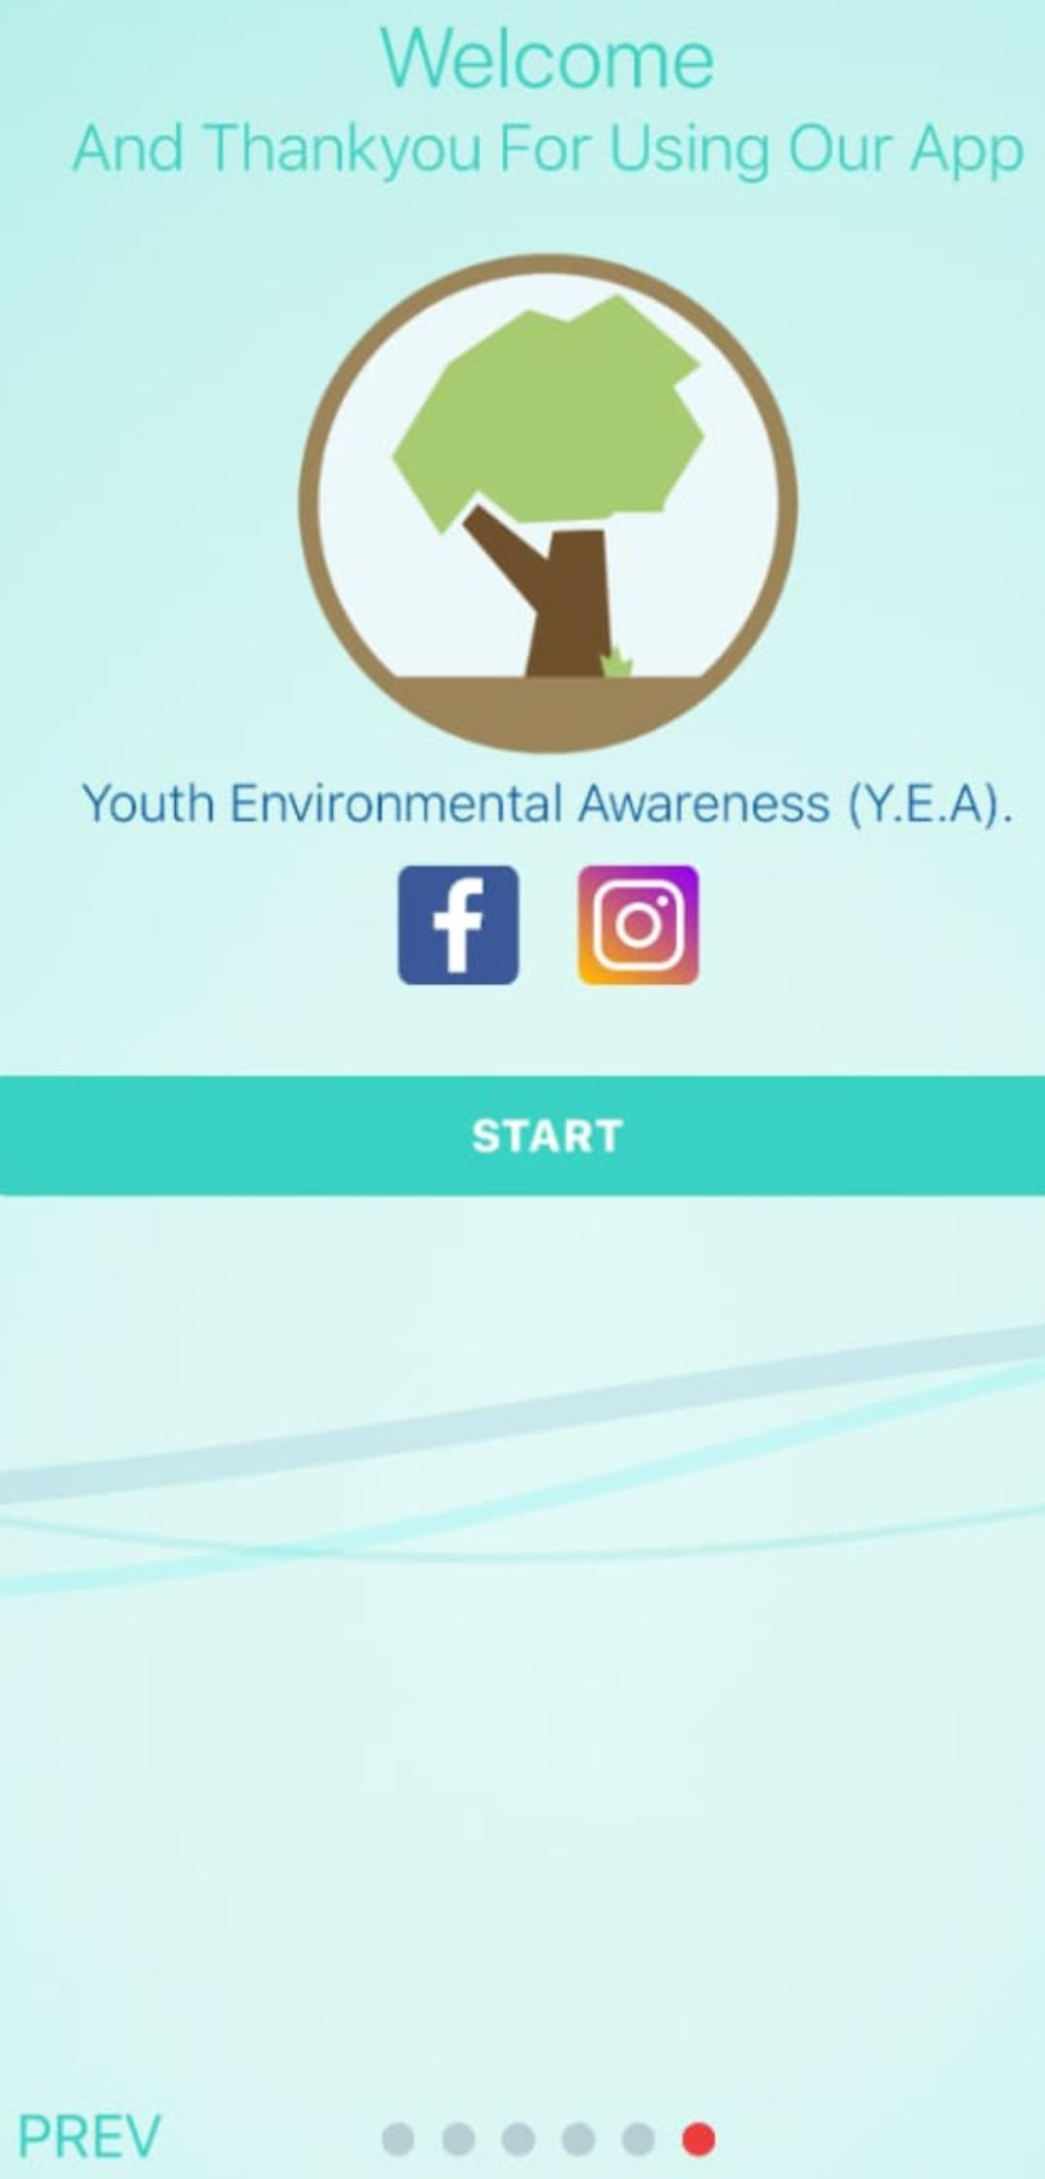

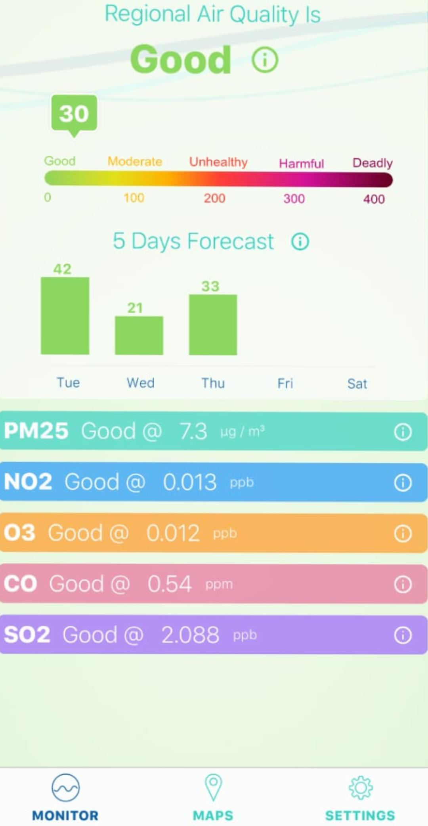

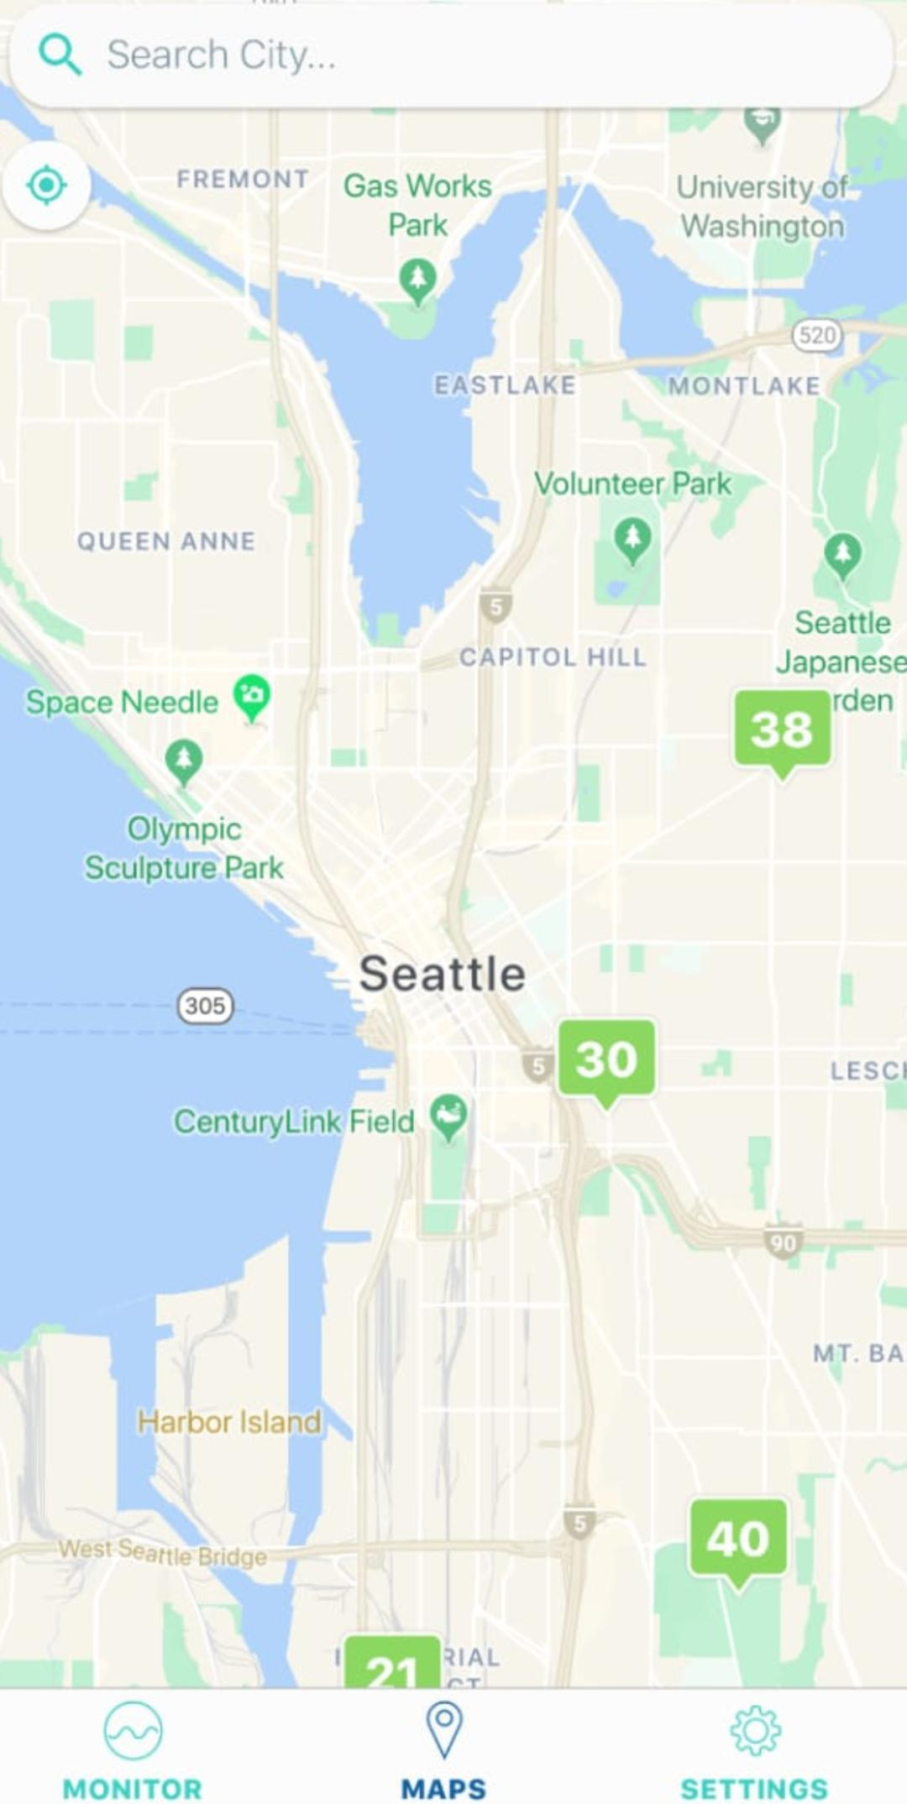

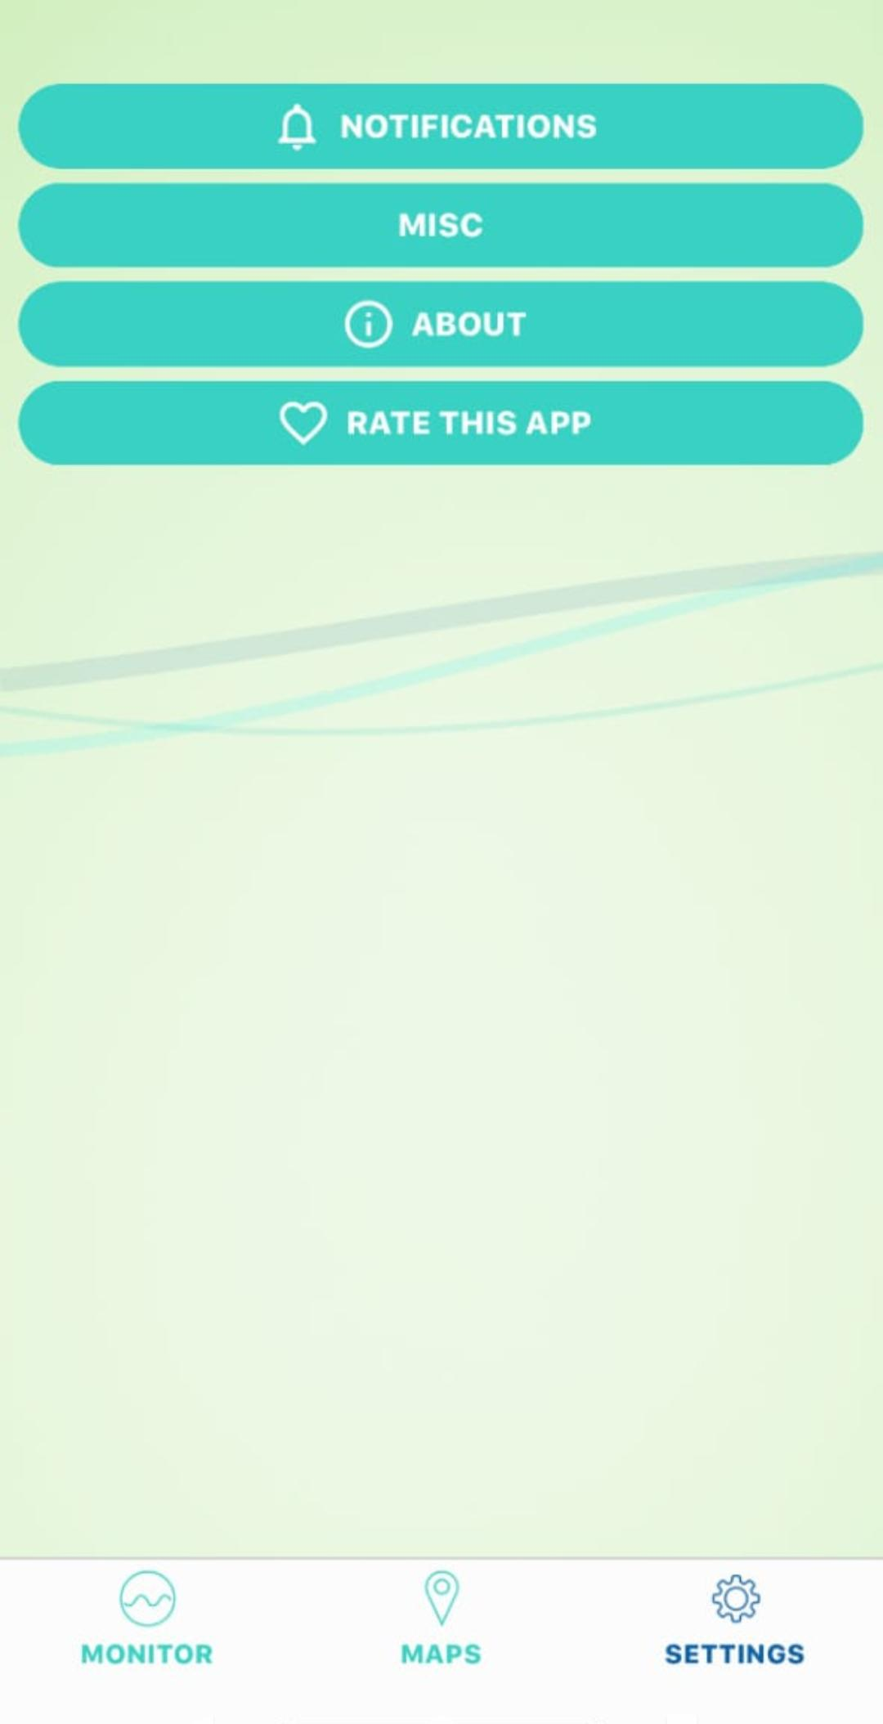

# Node-RED Vulnerabilities

Node-RED is “a programming tool for wiring together hardware devices, APIs and online services”, which provides a way of “low-code programming for event- driven applications” [36]. As an open-source platform, Node-RED is mainly tar- geted for deployment as a single-user platform, although it is also available on the IBM Cloud platform [23]

## Node-RED platform

A node is a reactive Node.js application triggered by receiving messages on at most one input port (dubbed *source*) and sending the results of (side-effectful) computations on output ports (dubbed *sinks*), which can be potentially multiple, unlike the input port. Figure 3 illustrates the code structure of a Node-RED node. A special type of node without sources and sinks, called *configuration* node, is used for sharing configuration data, such as login credentials, between multiple nodes.

A flow is a representation of nodes connected together. End users can either create their own flows on the platform’s environment or deploy existing flows pro- vided by the official Node-RED catalog [33] and by third particles.

.

Flow

message

Node

Node

ﬂow

context

Node

global

context

Flow

Node

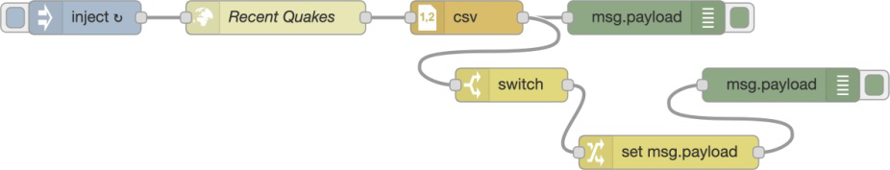

In Node-RED, *contexts* provide a shared communication channel between different nodes without using the explicit messages that pass through a flow [40]. Therefore the node wiring visible in the user interface reflects only a part of the information

flows that are possible in the flow. It introduces an implicit channel that is not visible to the user via the graphical interface of a flow. Node-RED defines three scope levels for the contexts

* + 1. **(b)**

Flow

Node

message Malicious

Node

ﬂow

context

Node

Node.js module

Node-RED

object

global

context

Flow

Malicious Node

Node.js

Node-RED

Flow

Malicious

Node

global

context

message

Node Node

ﬂow Malicious

context Node

Flow

**Program :**

{

"name": "virida",

"version": "0.1.1",

"description": "Virida Air Quality Monitor (AQS) (iOS & Android) app (built with React Native Hyperflow & Hypertoxin).",

"authors": [

"Tuan Le <tuan.t.lei@gmail.com> (https://github.com/tuantle)"

],

"license": "Virida, Inc",

"private": true,

"engines": {

"node": ">=9.x",

"npm": ">=5.x"

},

"dependencies": {

"@react-native-community/async-storage": "^1.5.0",

"@react-native-community/netinfo": "^3.2.1",

"color": "^3.1.2",

"hyperflow": "^0.2.1",

"hypertoxin": "^0.2.2",

"moment": "^2.24.0",

"prop-types": "^15.7.2",

"react": "^16.8.6",

"react-native": "^0.59.10",

"react-native-app-intro-slider": "^2.0.1",

"react-native-background-geolocation": "^3.0.6",

"react-native-code-push": "^5.6.0",

"react-native-collapsible": "^1.4.0",

"react-native-gesture-handler": "^1.3.0",

"react-native-google-places": "^3.0.5",

"react-native-maps": "^0.24.2",

"react-native-push-notification": "^3.1.3",

"react-native-rate": "^1.1.6",

"react-native-svg": "^9.5.1",

"react-native-svg-charts": "^5.2.0",

"react-native-webview": "^5.12.1",

"react-navigation": "^3.11.0",

"supercluster": "^6.0.1"

},

"devDependencies": {

"@babel/core": "^7.4.4",

"@babel/runtime": "^7.4.4",

"babel-eslint": "^10.0.2",

"babel-jest": "^24.8.0",

"eslint": "^6.0.1",

"eslint-plugin-react": "^7.14.2",

"eslint-plugin-react-native": "^3.7.0",

"jest": "^24.8.0",

"metro-react-native-babel-preset": "^0.54.1",

"react-test-renderer": "^16.8.6"

},

"jest": {

"preset": "react-native"

},

"scripts": {

"start-unit-tests": "NODE_ENV=development jest ./__tests__/test-suites",

"start-dev-sim": "NODE_ENV=development react-devtools & node node_modules/react-native/local-cli/cli.js start & react-native run-ios --configuration Debug simulator='iPhone 8'",

"start-dev": "NODE_ENV=development react-devtools & node node_modules/react-native/local-cli/cli.js start --reset-cache",

"start-dev-ios-device": "NODE_ENV=development react-devtools & node node_modules/react-native/local-cli/cli.js start & react-native run-ios --configuration Debug --device 'Belthasa'",

"start-staging-ios-device": "NODE_ENV=development node node_modules/react-native/local-cli/cli.js start & react-native run-ios --configuration Staging --device 'Belthasa'",

"start-production-ios-device": "NODE_ENV=development node node_modules/react-native/local-cli/cli.js start & react-native run-ios --configuration Release --device 'Belthasa'",

"build-ios-production": "NODE_ENV=production react-native bundle --dev false --platform ios --entry-file index.js --bundle-output ./ios/build/main.jsbundle --assets-dest ./ios/build",

"build-android-production": "NODE_ENV=production cd android && ./gradlew assembleRelease",

"enable-google-maps": "./node_modules/react-native-maps/enable-google-maps /Users/tuan/Projects/sdks/GoogleMaps-3.1.0/**"

},

"repository": {

"type": "git",

"url": "git+ssh://tuantle@bitbucket.org/tuantle/virida/virida.git"

},

"modulePathIgnorePatterns": [

"/node_modules/"

]

}

# 

## Security condition and enforcement

We leverage our trace-based semantics to define a semantics-based security con- dition. The condition is parametric on node-level security policies, represented as allowlists of API calls and accesses to the shared context. Then, we present the semantics of a fine-grained node-level monitor and prove its soundness and transparency with respect to the security condition.

# Conclusion

We have investigated the security of Node-RED, an open-source JavaScript- driven trigger-action platform. We have expanded on the recently-discovered critical exploitable vulnerabilities in Node-RED, where the impact ranges from massive exfiltration of data from unsuspecting users to taking over the entire platform. Motivated by the need for a security mechanism for Node-RED, we have proposed an essential model for Node-RED, suitable to reason about nodes and flows, be they benign, vulnerable, or malicious. We have formalized a prin- cipled framework to enforce fine-grained API control for untrusted Node-RED applications. Our formalization for a core language shows how to soundly and transparently enforce global security properties of Node-RED applications by local access checks, supporting module-, API-, value-, and context-level policies.

*Acknowledgments* This work was partially supported by the Swedish Foundation for Strategic Research (SSF), the Swedish Research Council (VR), and Digital Futures.

### Front-end development tools

Front-end development tools are focused on the user interface and user experience (UI-UX) and provide the following abilities:

* UI design tools
* SDKs to access device features
* Cross-platform accommodations/support

Notable tools are listed below.

#### First-Party

First party tools include official [SDKs](https://en.wikipedia.org/wiki/Software_development_kit) published by, or on behalf of, the company responsible for the design of a particular hardware platform (e.g. Apple, Google, etc) as well as any third-party software that is officially supported for the purpose of developing mobile apps for that hardware.

#### Third Party

### Security add-on layers

With [bring your own device](https://en.wikipedia.org/wiki/Bring_your_own_device) (BYOD) becoming the norm within more enterprises, IT departments often need stop-gap, tactical solutions that layer atop existing apps, phones, and platform component. Features include

* App wrapping for security
* Data encryption
* Client actions
* Reporting and statistics

### Mobile app testing

Mobile applications are first tested within the development environment using emulators and later subjected to [field testing](https://en.wikipedia.org/wiki/Field_testing). [Emulators](https://en.wikipedia.org/wiki/Emulator) provide an inexpensive way to test applications on mobile phones to which developers may not have physical access. The following are examples of tools used for testing application across the most popular [mobile operating systems](https://en.wikipedia.org/wiki/Mobile_operating_system).

* **Google Android Emulator** - an [Android](https://en.wikipedia.org/wiki/Android_(operating_system)) emulator that is patched to run on a Windows PC as a standalone app, without having to download and install the complete and complex [Android SDK](https://en.wikipedia.org/wiki/Android_SDK). It can be installed and Android compatible apps can be tested on it.
* **The official Android SDK Emulator** - a mobile device emulator which mimics all of the hardware and [software](https://en.wikipedia.org/wiki/Software) features of a typical mobile device (without the calls).
* **TestiPhone** - a [web browser](https://en.wikipedia.org/wiki/Web_browser)-based [simulator](https://en.wikipedia.org/wiki/Simulator) for quickly testing [iPhone](https://en.wikipedia.org/wiki/IPhone) [web applications](https://en.wikipedia.org/wiki/Web_applications). This tool has been tested and works using [Internet Explorer 7](https://en.wikipedia.org/wiki/Internet_Explorer_7), [Firefox 2](https://en.wikipedia.org/wiki/Firefox_2) and [Safari 3](https://en.wikipedia.org/wiki/Safari_3).
* **iPhoney** - gives a [pixel](https://en.wikipedia.org/wiki/Pixel)-accurate web browsing environment and it is powered by [Safari](https://en.wikipedia.org/wiki/Safari_(web_browser)). It can be used while developing [web sites](https://en.wikipedia.org/wiki/Web_sites) for the [iPhone](https://en.wikipedia.org/wiki/IPhone). It is not an iPhone simulator but instead is designed for web developers who want to create 320 by 480 (or 480 by 320) websites for use with iPhone. iPhoney will only run on [OS X](https://en.wikipedia.org/wiki/OS_X) 10.4.7 or later.
* **BlackBerry Simulator** - There are a variety of official BlackBerry simulators available to emulate the functionality of actual BlackBerry products and test how the device software, screen, keyboard and [trackwheel](https://en.wikipedia.org/wiki/Trackwheel) will work with application.
* **Windows UI Automation** - To test applications that use the Microsoft UI Automation technology, it requires Windows Automation API 3.0. It is pre-installed on Windows 7, Windows Server 2008 R2 and later versions of Windows.
* **MobiOne** Developer - a [mobile Web](https://en.wikipedia.org/wiki/Mobile_Web) [integrated development environment](https://en.wikipedia.org/wiki/Integrated_development_environment) (IDE) for [Windows](https://en.wikipedia.org/wiki/Windows) that helps developers to code, test, debug, package and deploy mobile [Web applications](https://en.wikipedia.org/wiki/Web_application) to devices such as [iPhone](https://en.wikipedia.org/wiki/IPhone), [BlackBerry](https://en.wikipedia.org/wiki/BlackBerry), [Android](https://en.wikipedia.org/wiki/Android_(operating_system)), and the [Palm Pre](https://en.wikipedia.org/wiki/Palm_Pre). MobiOne Developer was officially declared End of Life by the end of 2014.[[8]](https://en.wikipedia.org/wiki/Mobile_app_development#cite_note-8)